

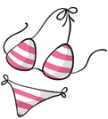
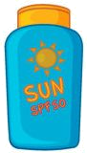



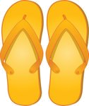





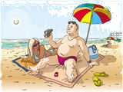
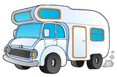
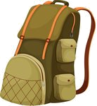
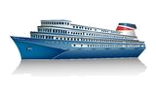
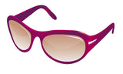


VACATION!:)
Choose the correct option.
a) hiking
b) climbing
c) diving

a) swimming trunks
b) swimsuit
c) bikini

a) cash
b) credit card
c) postcard

a) sand
b) sandcastle
c) sand toys

a) sun lotion
b) cocktail
c) juice

a) computer
b) camera
c) CD player

a) swimsuit
b) sandals
c) straw hat

a) shoes
b) flip flops
c) boots

a) city
b) town
c) village

a) football
b) beach ball
c) baseball

a) mountains
b) city
c) beach

a) water melon
b) tomato
c) cherry

a) caravan
b) hotel
c) cabin

a) train
b) motor home
c) bus

a) beach umbrella
b) hot air balloon
c) deckchair

a) snorkel gear
b) sunglasses
c) glass

a) sleeping
b) swimming
c) sunbathing

a) sailboat
b) ship
c) canoe

a) surfboard
b) banana
c) ice cream

a) schoolbag
b) suitcase
c) backpack

