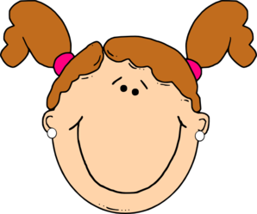
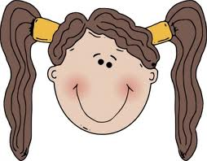
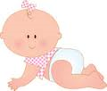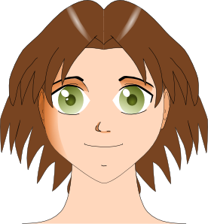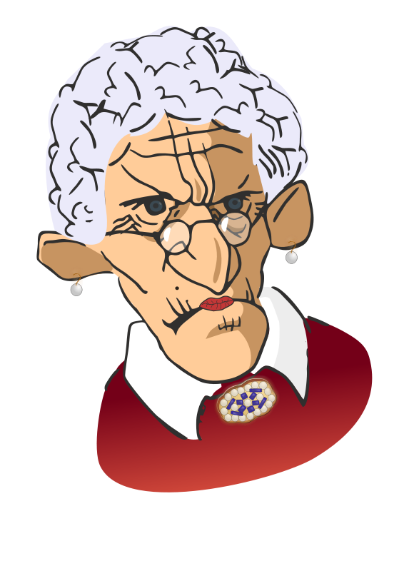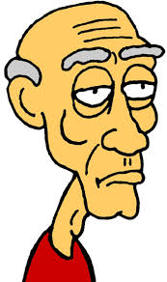
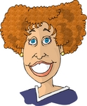

Baby
Teenager
Middle-aged woman
Old woman
Old man
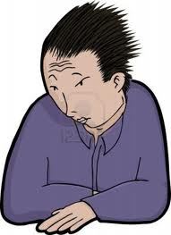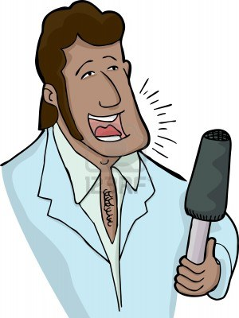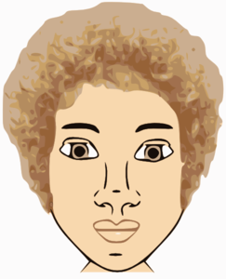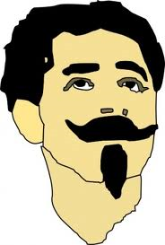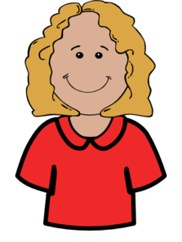
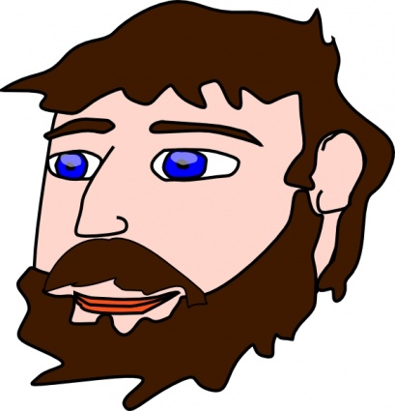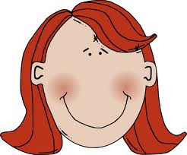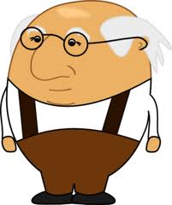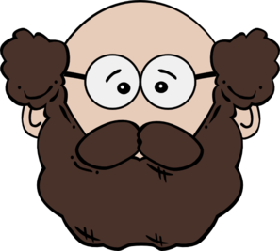
MATCH THE DEFINITIONS TO THE PICTURES
1.- He wears glasses. He’s got moustache and beard.
2.- She’s got medium-length blond hair and she’s smiling.
3.- He’s got dark spiky hair. He looks worried.
4.-He’s got dark hair, a moustache and a goatee.
5.-He’s an old man. He is bald and wears glasses. He’s got a big nose.
6.- She’s got medium-length red hair and small ears. She’s happy.
7.-He’s got blue eyes, brown hair and brown moustache.
8.-He’s got sideburns and dark hair. He is a singer.
9.- She’s got short brown curly hair and big eyes.

