 |  |  |  | 
 |  | 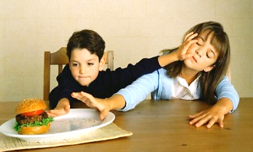 | 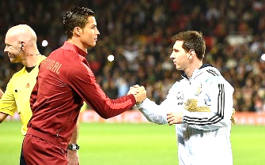 | 
 |  |  |  | 
 | 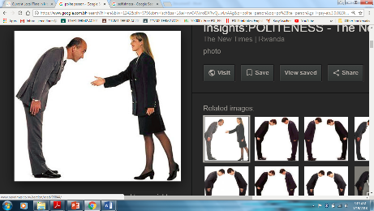 |  | 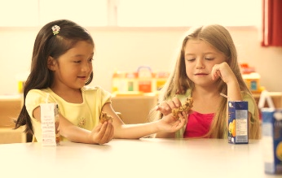 | 
DESCRIBING PERSONALITY – Look at the pictures and label each with the correct adjectives from the WORD BANK.
sad helpful angry crazy funny respectful smart lonely shy lazy selfish
clumsy generous talkative loud quiet happy friendly proud brave

b | e | a | u | t | i | f | u | l | x | a | b | c
d | e | f | g | h | j | k | l | m | n | o | p | f
s | f | r | q | t | h | s | h | y | l | o | a | r
c | h | o | n | e | s | t | v | z | d | s | h | i
f | b | c | e | f | y | u | r | t | p | m | t | e
r | o | p | a | u | s | t | d | c | v | a | i | n
e | f | r | t | n | w | l | w | i | q | r | k | d
s | z | u | r | n | o | n | a | n | o | t | i | l
p | g | a | g | y | X | c | w | z | j | g | l | y
e | s | e | l | b | w | u | i | k | y | a | m | j
c | g | u | t | h | r | c | e | u | b | g | u | q
t | s | o | w | d | w | z | r | p | i | o | p | u
f | j | r | o | g | x | v | t | a | m | k | j | h
u | z | x | y | d | l | s | e | l | z | a | e | a
l | m | g | a | g | a | g | o | o | j | y | r | p
s | a | e | t | a | n | g | a | i | s | i | u | p
h | q | h | e | l | p | f | u | l | i | l | k | y
WORD SEARCH BANK

beautiful helpful lazy
smart friendly honest
good crazy respectful
funny shy happy

Exercise 3 Fill in the gaps. Use the adjectives.
1. Anne is constantly on the phone. She's so ____________________.
2. Still in bed at lunch-time! Come on! Get up! You ____________________boy.
3. Be careful when put the plates in the cupboard! You're so ____________________.
4. Don't just think of yourself, that's so ____________________.

5. I love Anna! She makes friends very easily, she's very ____________________.
6. Tom is a great guy but he doesn't speak much, he's rather ____________________.
Exercise 4. What are you like? Complete the sentences, then tell the class.

1. I am very ____________________ 2. I am a little _________________ 3. I am not very _________________
4. I want to be a ___________________ person. 5. I don’t like __________________ people because it annoys me.

