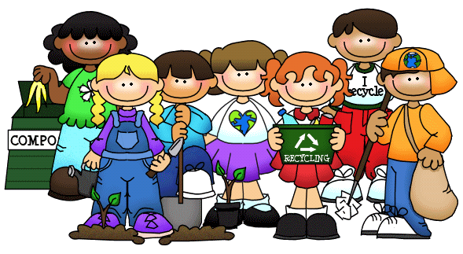
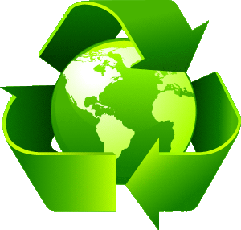
Be green!

 Look at the picture and complete the phrases.

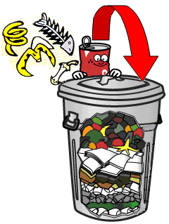
1.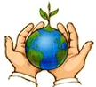 2.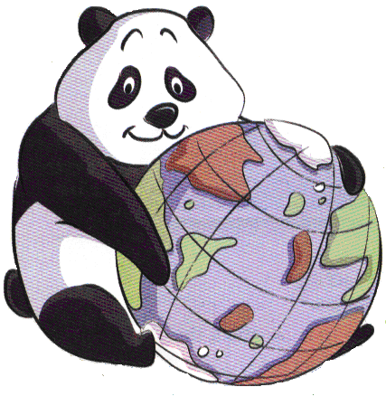 3. 4. 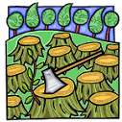
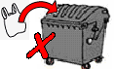
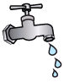
5. 6. 7.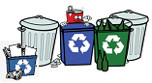 8. 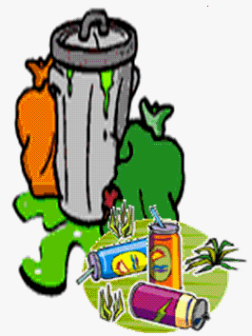
9. 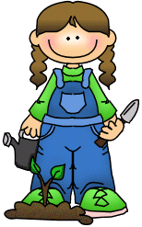 10.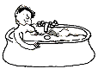 11.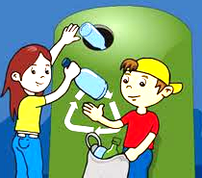 12.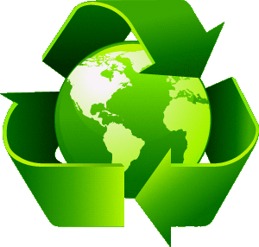

1. ...................................... the planet.
2. ...................................... animals.
3. ....................................... rubbish in the bin.
4. ....................................... trees.
5. ....................................... plastic bags.
6. ........................................ water.
7. ....................................... bottles, cans & paper.
8. ....................................... rubbish on the ground.
9. ........................................ trees.
10. ..................................... baths.
11. ..................................... glass in the green bin.
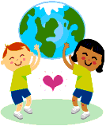
12. ..................................... green.

