1. I…football now.

a. am playing
b. am play
c. play
d. playing
2. He…a car now.

a. is drive
b. driving
c. drives
d. is driving
3. They…TV.

a. is watching
b. are watching
c. are watch
d. watches
4. We…a picnic at the moment.

a. are having
b. are have
c. having
d. has
5. She…a book now.

a. reads
b. am reading
c. is reading
d. is read

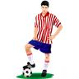
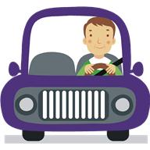
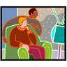
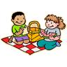
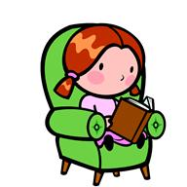

6. It….

a. am rain
b. is raining
c. rain
d. is rains
8. Jane…her homework at the moment.

a. is does
b. are doing
c. does
d. is doing
10. They…fun.

a. have
b. are have
c. is having
d. are having
7. You…a kite in the park.

a. am flying
b. are fly
c. are flying
d. is fly
9. I…my homework at the moment.

a. am doing
b. do
c. am do
d. is doing
12. I…this morning.

a. am running
b. are running
c. run
d. am run
14. She…tennis now.

a. am playing
b. are playing
c. is playing
d. plays
16. Ssh! Mary….

a. is sleeping
b. are sleeping
c. sleeping
d. is sleep
18. Mandy….on the board.

a. am writing
b. is write
c. write
d. is writing
20. Jack…his lunch at now.

a. is have
b. is having
c. am having
d. have
22. The sun…now.

a. is shining
b. am shining
c. shine
d. shining
24. They…now.

a. am swimming
b. are swim
c. are swimming
d. swims
26. We…now.

a. is singing
b. sing
c. singing
d. are singing
28. Jim…a banana now.

a. are eating
b. is eating
c. eating
d. is eat
30. I…volleyball now.

a. am play
b. am playing
c. play
d. playing
11. My Granny and I … the dinner.

a. am preparing
b. are preparing
c. preparing
d. prepares
13. Tim and Tina… about going on holiday.

a. is dreaming
b. dreaming
c. are dream
d. are dreaming
15. John…the piano.

a. is practising
b. am practising
c. practising
d. practise
17. They…for the bus.

a. waiting
b. am waiting
c. are wait
d. are waiting
19. I…the carpets now.

a. am hoover
b. are hoovering
c. am hoovering
d. hoovering
21. Betty…her bike today.

a. riding
b. are riding
c. is ride
d. is riding
23. He…golf today.

a. playing
b. are playing
c. is play
d. is playing
25. Kate…to music at the moment.

a. is listening
b. are listening
c. listening
d. listens
27. She…at the moment.

a. phoning
b. is phone
c. is phoning
d. phone
29. They…today.

a. are skiing
b. is skiing
c. sky
d. ski


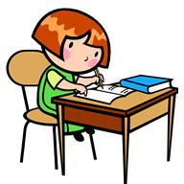
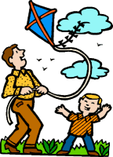
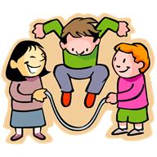


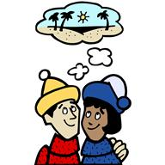
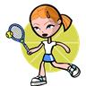
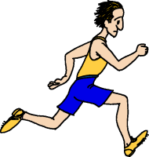
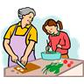
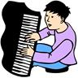

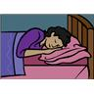

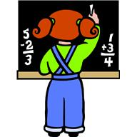
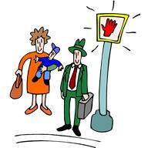
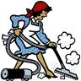

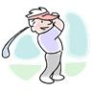


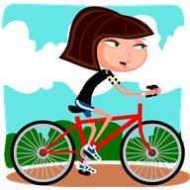
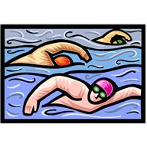


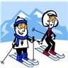
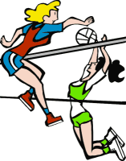
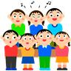


1. I…football now.

a. am playing
b. am play
c. play
d. playing
2. He…a car now.

a. is drive
b. driving
c. drives
d. is driving
3. They…TV.

a. is watching
b. are watching
c. are watch
d. watches
4. We…a picnic at the moment.

a. are having
b. are have
c. having
d. has
5. She…a book now.

a. reads
b. am reading
c. is reading
d. is read

6. It….

a. am rain
b. is raining
c. rain
d. is rains
8. Jane…her homework at the moment.

a. is does
b. are doing
c. does
d. is doing
10. They…fun.

a. have
b. are have
c. is having
d. are having
7. You…a kite in the park.

a. am flying
b. are fly
c. are flying
d. is fly
9. I…my homework at the moment.

a. am doing
b. do
c. am do
d. is doing
12. I…this morning.

a. am running
b. are running
c. run
d. am run
14. She…tennis now.

a. am playing
b. are playing
c. is playing
d. plays
16. Ssh! Mary….

a. is sleeping
b. are sleeping
c. sleeping
d. is sleep
18. Mandy….on the board.

a. am writing
b. is write
c. write
d. is writing
20. Jack…his lunch at now.

a. is have
b. is having
c. am having
d. have
22. The sun…now.

a. is shining
b. am shining
c. shine
d. shining
24. They…now.

a. am swimming
b. are swim
c. are swimming
d. swims
26. We…now.

a. is singing
b. sing
c. singing
d. are singing
28. Jim…a banana now.

a. are eating
b. is eating
c. eating
d. is eat
30. I…volleyball now.

a. am play
b. am playing
c. play
d. playing
11. My Granny and I … the dinner.

a. am preparing
b. are preparing
c. preparing
d. prepares
13. Tim and Tina… about going on holiday.

a. is dreaming
b. dreaming
c. are dream
d. are dreaming
15. John…the piano.

a. is practising
b. am practising
c. practising
d. practise
17. They…for the bus.

a. waiting
b. am waiting
c. are wait
d. are waiting
19. I…the carpets now.

a. am hoover
b. are hoovering
c. am hoovering
d. hoovering
21. Betty…her bike today.

a. riding
b. are riding
c. is ride
d. is riding
23. He…golf today.

a. playing
b. are playing
c. is play
d. is playing
25. Kate…to music at the moment.

a. is listening
b. are listening
c. listening
d. listens
27. She…at the moment.

a. phoning
b. is phone
c. is phoning
d. phone
29. They…today.

a. are skiing
b. is skiing
c. sky
d. ski

