We use Present Continuous for:
* something that is happening at or around the moment of speaking (the action is not finished);

e.g. (+) The water is boiling. Can you turn it off?
( - ) Let’s go out. It isn’t raining now.
( ? ) What are you doing in the kitchen, dad?

* a temporary situation;

e.g. (+) I am living with some friends until I find a flat.
( - ) “You are working very hard today.” “Yes, I’ve got a lot to do.”
( ? ) “What are you learning?” “Maths.”
We use Present Simple for:
* things in general or things that happen repeatedly;

e.g. (+) Water boils at 100⁰Celsius.
( - ) It doesn’t rain very much in summer.
( ? ) What do you usually do at weekends?

* a permanent situation;

e.g. (+) My parents live in London.
( - ) He is lazy. He doesn’t work very hard most of the time.
( ? ) What subjects do you learn at school?

Choose the correct answer:


- Every day he ....... a bottle of
beer.
a) is drinking
b) drinks
c) drink
d) are drinking

- She ........ a good novel at
present.
a) read
b) reads
c) is reading
d) are reading

- He ................ a sandwich
now.

a) eats
b) are eating
c) eat
d) is eating

- They usually .......... a party
on Saturdays.

a) are having
b) have
c) has
d) is having

- Fred usually .... football on
Sunday morning.
a) plays
b) are playing
c) is playing
d) play

- Margaret .... tennis at
the moment.
a) plays
b) are playing
c) is playing
d) play

- He has so much money that
he ...... a new car every year.
a) buy
b) are buying
c) is buying
d) buys

- I ........... to school every
weekday.
a) go
b) am going
c) goes
d) is going

- “Where are you going?”
“I…… to school.”

a) go
b) am going
c) are going
d) goes

- We often ....... a roast
chicken on Sundays.

a) eat
b) is eating
c) are eating
d) eats
- We ............. pizza
right now.
a) eat
b) is eating
c) are eating
d) eats

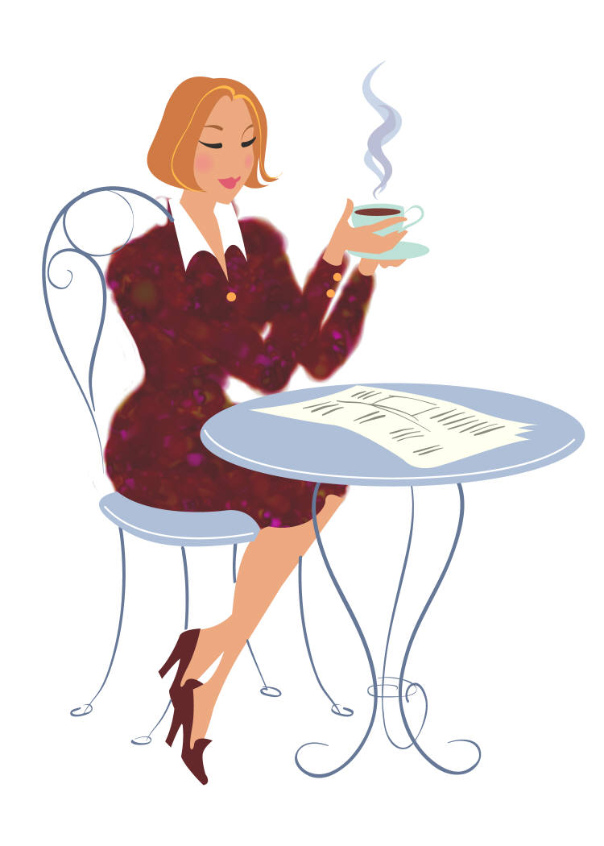
- She ..............
a coffee at the
moment.
a) have
b) is having
c) are having
d) has

13. They always ….. their presents under the Christmas tree.
a) find
b) finds
c) are finding
d) is finding

14. It ......... very often in this
country.
a) rain
b) is raining
c) rains
d) are raining

15. I ………….. .
a) don’t smoke
b) am not smoking
c) doesn’t smoke
d) don’t smokes


- In her free time she......
books.
a) read
b) reads
c) is reading
d) are reading

- We often ................. fruit
and vegetables.

a) are buying
b) buys
c) is buying
d) buy

- I .......... a shower
every day.
a) have
b) am having
c) has
d) is having

- He often ..............
TV in the evening.

a) watch
b) is watching
c) are watching
d) watches

- “David, what ........ you
…….?” “I am
reading a book.”

a) do/do
b) are/doing
c) are /do
d) does/doing

- They usually .... ten miles
every day.

a) are cycling
b) cycle
c) cycles
d) is cycling


- It ..... very often in
winter.
a) is snowing
b) snow
c) are snowing
d) snows

- .... she often .... juice for
breakfast?

a) Does/drink
b) Is/drinking
c) Do/drinks
d) Is/drinks
- The children usually
.... snowmen in winter.

a) makes
b) are making
c) make
d) is making

- I never ..... letters in my
office.
a) type
b) is typing
c) am typing
d) types

- I ...... all the
letters at the
moment.
a) type
b) am typing
c) is typing
d) types


- We usually ..... coffee after
dinner.
a) have
b) is having
c) are having
d) has

- On Sundays he usually ....
at 11 o’clock.
a) get up
b) gets up
c) are getting up
d) is getting up

- I often ...........
to the radio.
a) listens
b) listen
c) is listening
d) are listening

- We always ......
tennis at six.
a) plays
b) play
c) are playing
d) is playing

- The weather is fantastic! It’s

warm and the sun ….. . Let’s have a picnic!

a) shines
b) shine
c) is shining
d) are shining
- I often ..........
milk before
going to bed.
a) drink
b) drinks
c) am drinking
d) are drinking

- Shhh! Be quiet. The
baby……. .
a) sleeps
b) are sleeping
c) is sleeping
d) sleep

- They never ...... chess on
Sundays.
a) are playing
b) is playing
c) play
d) plays

- They .........
a party just now.
a) have
b) are having
c) has
d) is having

- I always............. breakfast in
the morning.

a) have
b) has
c) am having
d) are having

- He ........ his dog for a walk 3
times a day.
a) are taking
b) is taking
c) take
d) takes

- I rarely ............. junk
food.
a) is eating
b) am eating
c) eat
d) eats

- My ballet lessons ............. at
5 o’clock every day.

a) start
b) starts
c) is starting
d) are starting

We use Present Simple for:
* things in general or things that happen repeatedly;

e.g. (+) Water boils at 100⁰Celsius.
( - ) It doesn’t rain very much in summer.
( ? ) What do you usually do at weekends?

* a permanent situation;

e.g. (+) My parents live in London.
( - ) He is lazy. He doesn’t work very hard most of the time.
( ? ) What subjects do you learn at school?
We use Present Continuous for:
* something that is happening at or around the moment of speaking (the action is not finished);

e.g. (+) The water is boiling. Can you turn it off?
( - ) Let’s go out. It isn’t raining now.
( ? ) What are you doing in the kitchen, dad?

* a temporary situation;

e.g. (+) I am living with some friends until I find a flat.
( - ) “You are working very hard today.” “Yes, I’ve got a lot to do.”
( ? ) “What are you learning?” “Maths.”

Choose the correct answer:

- Every day he ....... a bottle of
beer.
a) is drinking
b) drinks
c) drink
d) are drinking

- She ........ a good novel at
present.
a) read
b) reads
c) is reading
d) are reading

- He ................ a sandwich
now.
a) eats
b) are eating
c) eat
d) is eating

- They usually .......... a party
on Saturdays.
a) are having
b) have
c) has
d) is having

- Fred usually .... football on
Sunday morning.

a) plays
b) are playing
c) is playing
d) play

- Margaret .... tennis at
the moment.
a) plays
b) are playing
c) is playing
d) play

- He has so much money that
he ...... a new car every year.
a) buy
b) are buying
c) is buying
d) buys

- I ........... to school every
weekday.
a) go
b) am going
c) goes
d) is going

- “Where are you going?”
“I…… to school.”
a) go
b) am going
c) are going
d) goes

- We often ....... a roast
chicken on Sundays.
a) eat
b) is eating
c) are eating
d) eats

- We ............. pizza
right now.
a) eat
b) is eating
c) are eating
d) eats

- She ..............
a coffee at the
moment.
a) have
b) is having
c) are having
d) has

- They always ..... their
presents under the
Christmas tree.
a) find
b) finds
c) are finding
d) is finding

- It ......... very often in this
country.
a) rain
b) is raining
c) rains
d) are raining

- I ………….. .
a) don’t smoke
b) am not smoking
c) doesn’t smoke
d) don’t smoke

- In her free time she......
books.
a) read
b) reads
c) is reading
d) are reading

- We often ................. fruit
and vegetables.

a) are buying
b) buys
c) is buying
d) buy

- I .......... a shower
every day.
a) have
b) am having
c) has
d) is having

- He often ..............
TV in the evening.

a) watch
b) is watching
c) are watching
d) watches

- “David, what ........ you
…….?” “I am
reading a book.”

a) do/do
b) are/doing
c) are /do
d) does/doing

- They usually .... ten miles
every day.

a) are cycling
b) cycle
c) cycles
d) is cycling

- It ..... very often in
winter.
a) is snowing
b) snow
c) are snowing
d) snows

- .... she often .... juice for
breakfast?

a) Does/drink
b) Is/drinking
c) Do/drinks
d) Is/drinks
- The children usually
.... snowmen in winter.

a) makes
b) are making
c) make
d) is making

- I never ..... letters in my
office.
a) type
b) is typing
c) am typing
d) types

- I ...... all the
letters at the
moment.

a) type
b) am typing
c) is typing
d) types

- We usually ..... coffee after
dinner.

a) have
b) is having
c) are having
d) has

- On Sundays he usually ....
at 11 o’clock.
a) get up
b) gets up
c) are getting up
d) is getting up

- I often ...........
to the radio.
a) listens
b) listen
c) is listening
d) are listening

- We always ......
tennis at six.

a) plays
b) play
c) are playing
d) is playing

- The weather is fantastic! It’s

warm and the sun ….. . Let’s have a picnic!

a) shines
b) shine
c) is shining
d) are shining
- I often ..........
milk before
going to bed.
a) drink
b) drinks
c) am drinking
d) are drinking

- Shhh! Be quiet. The
baby……. .
a) sleeps
b) are sleeping
c) is sleeping
d) sleep

- They never ...... chess on
Sundays.
a) are playing
b) is playing
c) play
d) plays

- They .........
a party just now.
a) have
b) are having
c) has
d) is having

- I always............. breakfast in
the morning.

a) have
b) has
c) am having
d) are having

- He ........ his dog for a walk 3
times a day.
a) are taking
b) is taking
c) take
d) takes

- I rarely ............. junk
food.
a) is eating
b) am eating
c) eat
d) eats

- My ballet lessons ............. at
5 o’clock every day.

a) start
b) starts
c) is starting
d) are starting

