Containers
Many items that we buy come in containers. Containers may have a specific name depending on their shape and the material they are made of.
In this lesson, learn the vocabulary for various containers and click on each link to listen to the sound file. Below, find the same vocabulary with corresponding photos.
Theses are the names of some common materials used to make containers:
Aluminum
Canvas
Cardboard
Ceramic
Metal
Paper
Plastic
Wood
Here are images that show different types of containers.
Bag / Sack – Bag and sack are synonyms.
Some regions of North America tend to use one term more than the other.
canvas carrying bag | paper shopping bag | plastic bag
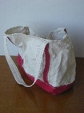 | 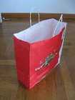 | 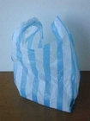
bag of flour | bag of compost
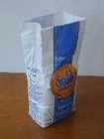 | 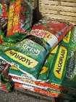
Barrel
Wood
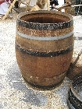
Basket – Baskets are often made from woven natural materials including
grass, wood strips, and reeds. Now, many baskets are also made of plastic.
plastic | grass | wood strips
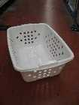 | 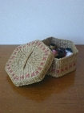 | 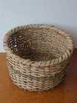
grocery basket | laundry basket
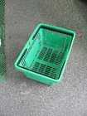 | 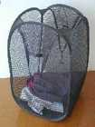
Bottle
glass wine bottle | plastic water bottle | plastic shampoo bottle
 | 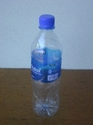 | 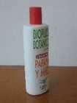
Box
cardboard box | box of tissues | box of matches
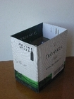 | 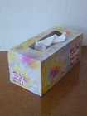 | 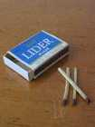
plastic box | wooden box
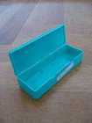 | 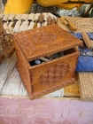
Bucket / Pail
plastic | wood | metal
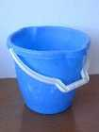 | 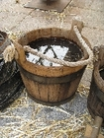
Can – A can refers to a container made of metal. Some of these containers
are now made of plastic but they continue to be referred to as "cans."
garbage cans
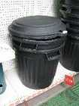 | 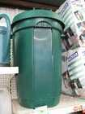
watering can | gas can / container
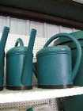 | 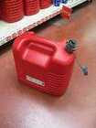
can of soda | can of olives | spray can
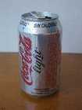 | 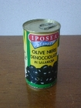 | 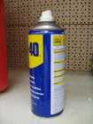
Carton (paper)
egg carton | milk carton | carton of cigarettes
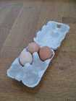 | 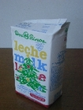
Case
glasses case | paint set case
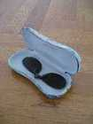 | 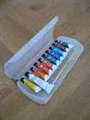
case of beer | suitcase | CD/DVD case
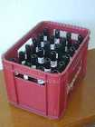 | 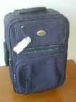
Chest
ice chest
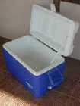
Crate
fruit crate | vegetable crate
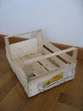
Envelope
manila envelope | letter envelope | padded envelope
Jar – Jars are only made of glass.
The difference between a bottle and a jar is a bottle has a small mouth.
Usually, the mouth of a jar is the same diameter as the jar itself.
jar of peanut butter | glass jar | storage jar
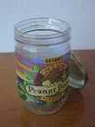 | 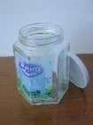 | 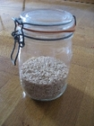
Jug
plastic (5 liter)
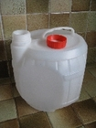
Pack
pack of chewing gum | pack of cigarettes
Pitcher
ceramic | glass | plastic
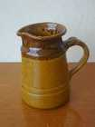 | 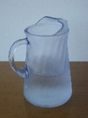 | 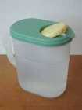
Tray – Trays are usually shallow (sides not deep), flat, rectangular containers.
metal cooking tray | aluminum cookie tray /  cookie sheet | plastic ice cube tray
 | 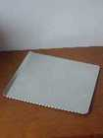 | 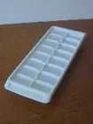
wood serving tray | plastic paper tray
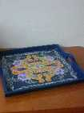 | 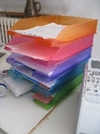
Tub
tub of ice cream
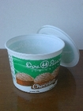
Tube – Tubes are cylindrical and may open at both ends or just one end.
cardboard tube | plastic tube of lotion | metal toothpaste tube
 | 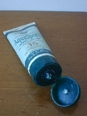
Other containers
food storage containers | trash receptacle /  container / can
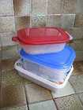 | 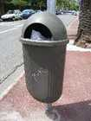
container ship

