New Zealand
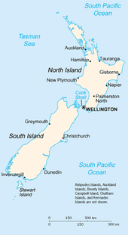
New Zealand is situated southeast of A and consists of two large islands: N and S . The islands were discovered by a Dutch explorer Abel T in 1642. So it was a Dutch colony and later Captain James C claimed the country for Great Britain in 1769. New Zealand was named after a part of Holland – Zealand.
The capital is W .Another major city is A and CH .The original inhabitants are the M who were originally cannibals of Polynesian origin. New Zealanders are called k . The favorite sport is r .
The country is hilly and picturesque with rocks, volcanoes, hot springs, mud pools and geysers. The characteristics of the New Zealand are evergreen forest with warm climate. The highest peak is Mt. C (3 764m). Almost all the rivers are short and most of them run swiftly to the sea. The largest lake is Taupo in the North Island.
The flag is very similar to the Australian one with Southern Cross and Union Jack.
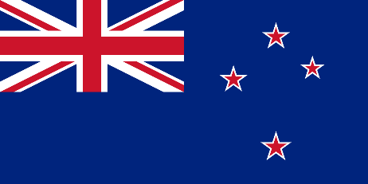 .

Typical animals: kiwi, brown emu, Kakapo parrot, albatrosses, penguins, largest insect weta and tuatara.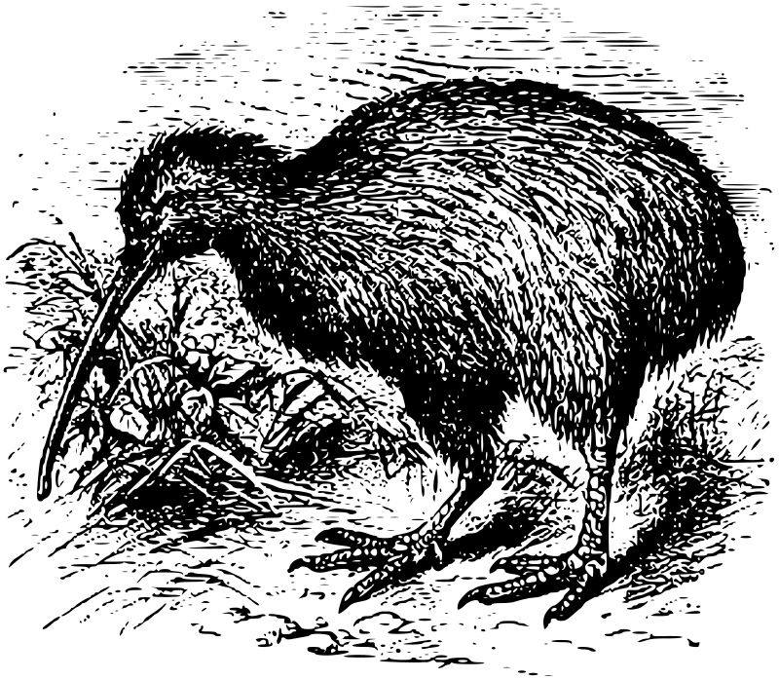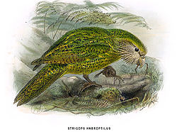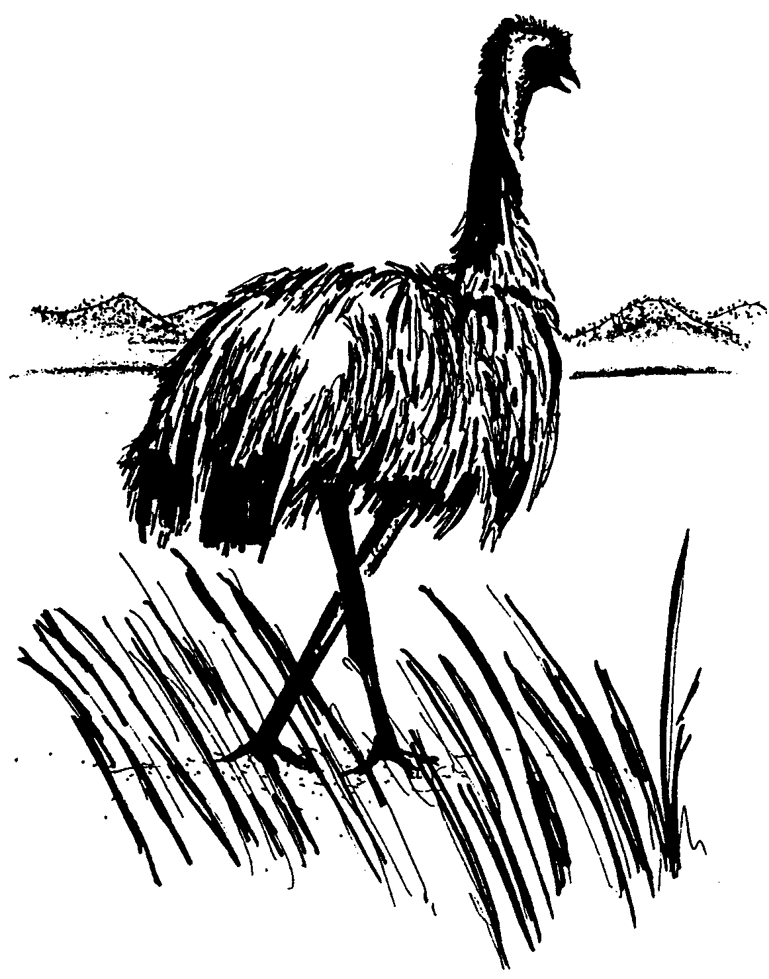 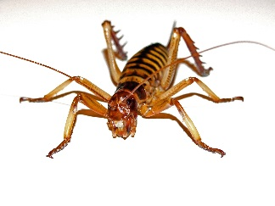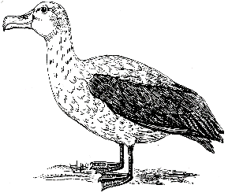

Famous New Zealanders
Sir Edmund Hillary movie actor
Bruce McClaren the first woman to flight between England and Australia
Kiri Te Kanawa opera singer
Russell Crowe motor racer
Jean Batten the first men to climb Mount Everest

Film makers often use the countryside for making films, the Oscar winning film Lord of the Rings was shot there. New Zealand was the first country in the world in 1893 to give women the right to vote.
In New Zealand you can find unique kinds of plants and animals, which do not grow and do not live anywhere in the world. About a quarter of the land is forested in areas which are largely protected from commercialisation in national parks.

New Zealand is situated southeast of Australia and consists of two large islands: North and South. The islands were discovered by a Dutch explorer Abel Tasman in 1642. So it was a Dutch colony and later Captain James Cook claimed the country for Great Britain in 1769. New Zealand was named after a part of Holland – Zealand.
The capital is Wellington .Another major city is Auckland and Christchurch .The original inhabitants are the Maoris who were originally cannibals of Polynesian origin. New Zealanders are called kiwis. The favourite sport is ragby.
The country is hilly and picturesque with rocks, volcanoes, hot springs, mud pools and geysers. The characteristics of the New Zealand are evergreen forest with warm climate. The highest peak is Mt. Cook (3 764m). Almost all the rivers are short and most of them run swiftly to the sea. The largest lake is Taupo in the North Island.
The flag is very similar to the Australian one with Southern Cross and Union Jack.

Animals – picture of kiwi, Kakapo parrot, brown emu, weta, albartoss

Sir Edmund Hillary the first men to climb Mount Everest
Bruce McClaren motor racer
Kiri Te Kanawa opera singer
Russell Crowe movie actor
Jean Batten the first woman to flight between England and Australia

