INDIA AND SOUTH AFRICA

INDIA
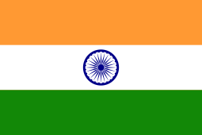
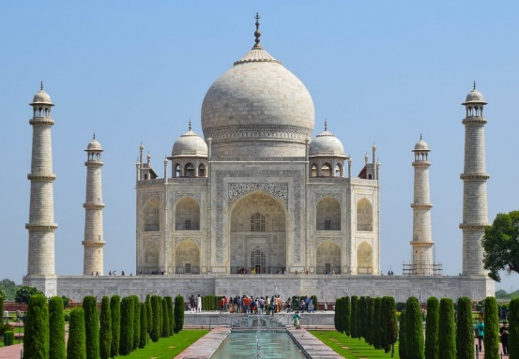
India is in Asia. It is the second largest country in the world in terms of population, behind China. In India, there are around 1,3 billion (1 300 000 000) people. Hinduism is a big religion in India, and they have many temples. The Taj Mahal is in India, and is a very impressive building.

The capital of India is New Delhi, but the biggest city is Mumbai. The Indian flag is a blue wheel on orange, white and green stripes. It looks like this:

SOUTH AFRICA
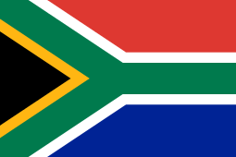
South Africa is at the southern tip of Africa. There are around 50 million people (50 000 000) living in South Africa. There are eleven different languages spoken in South Africa, including Zulu, Xhosa and Afrikaans. South Africa gets many tourists visiting because of its biodiversity, national parks, and beautiful beaches.
Unlike most other countries, South Africa has 3 capitals. They are Pretoria, Johannesburg and Cape Town. The South African flag has six different colours, and looks like this:
DO YOU REMEMBER?

- What is the capital of India?
_____________________

- How many capitals does South Africa have?
______________________
- How many people live in India?
______________________

- How many languages are there in South Africa?
______________________

- What is Hinduism?

______________________

- In which continent is India?
______________________

- How many colours are there in the South African flag?
______________________

- Why do tourists go to South Africa?
______________________

DRAW THE FLAGS!

INDIA SOUTH AFRICA

