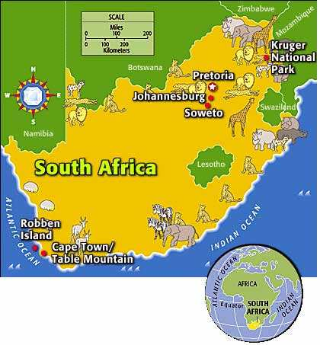
LEARN ABOUT SOUTH AFRICA

- A little bit of geography.
The Republic of South Africa is located in the ................. of the African continent. South Africa is bordered by (= bordé(e) par) the............................... Ocean and the ................................. Ocean.
The capital is named P............................ but it has also got a nickname (=surnom) : “the city of Jacaranguas” because there are many beautiful trees in the city.

- The official languages
South Africa has 11 official languages.
- E............................ is recognized as the language of commerce and science.
- At home, most people (= la plupart des gens) speak Z............................... (23.8%), Xhosa (17.6%) and A............................... (13.3%).
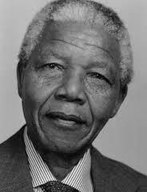
- South Africa and racism
Nelson M............................ was a great political leader. He fought against (=il s’est battu contre) racism in South Africa. In _ _ _ _ (date) he received the Nobel Peace Prize. In _ _ _ _ (date) he became the first black President of the Republic of South Africa. His nickname is .......................... it was the name of a clan he was a member of.

- The flag of the Republic of South Africa is b......................, y......................, g....................., w......................., r............. and b...................... (colours) .The flag was created in _ _ _ _ (date). It is multi-coloured and is a symbol for the r............................ nation.

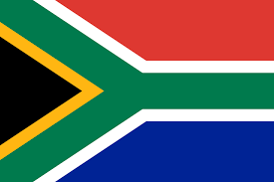
- The horizontal Y means ..............................................................
WORD BANK : Pretoria – Rainbow – 1994 – Zulu – Afrikaans – people of European origin ; Atlantic - black people – unity – blood – the land – natural resources – indian - gold – Madiba – English – the sky and oceans – south – Mandela – 1993
- Black means .............................................................................
- Yellow means ...........................................................................
- Green means .............................................................................
- White means .............................................................................
- Red means ................................................................................
- Blue means ...............................................................................

