**The United States of America**

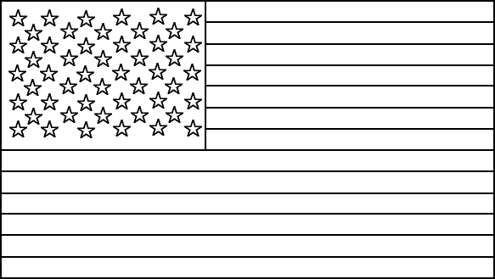**Basic facts about the United States of America**

The USA is made up of ____ states and a **federal district** (District of Columbia). Two states, A_______ and H________, are not directly **attached to** the continental US. It is the third most populated country in the ________, with more than 300 million **inhabitants**. The main spoken __________ in the United States is English, but in many areas Spanish is _____________.

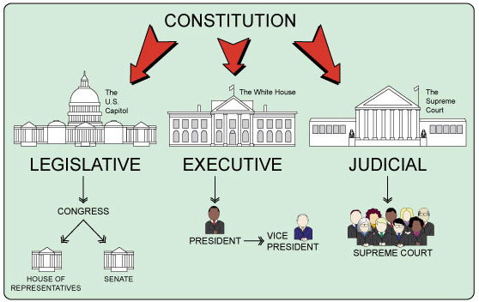

**The American system of government**

The US is a f_ _ _ _ _ _ state also called a u _ _ _ _ of self-governing states united by a **central government**. The head of each state is the **governor**.

The **federal government** c _ _ _ _ _ _ _ of **3 branches**. The law-making or **legislative power** is concentrated in C _ _ _ _ _ _ _ which is divided into the S _ _ _ _ _ and the H _ _ _ _ of **Representatives**. There are 435 members in the House of Representatives and 100 senators, _ from each state. The president **is the head of** the **e _ _ _ _ _ _ _ _ power** represented by the federal government. The S_ _ _ _ _ _ Court holds **judicial power**.

**American history**

1. The US gained its independence from Britain
2. The American Civil War was fought
3. The US suffered from a terrorist attack
4. the US entered into the Second World War

⬜ from 1861–1865

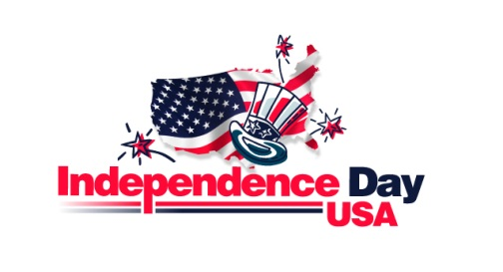 ⬜ on December 7, 1941

⬜ on 4 July, 1776

⬜ on September 11, 2001

⬜ and it is now celebrated as **Independence Day** also called the Fourth of July.

⬜ during which the World Trade Towers in New York City were completely destroyed and the Pentagon in Washington, DC was severely damaged.

⬜ 11 Southern **slave‑keeping states** declared their separation from the US and formed **the Confederacy**. They fought against the Northern States also known as **the Union** - the states where slavery had been abolished.

⬜ after the surprise Japanese attack on the US Naval base in **Pearl Harbour**, Hawaii

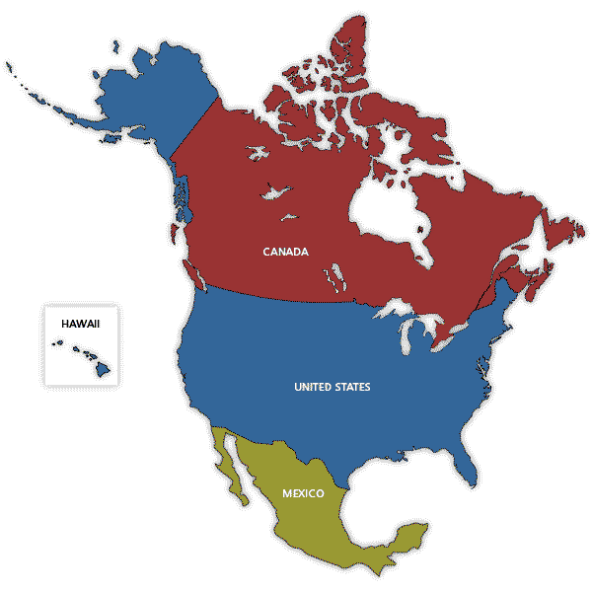

**Geographical features**

The US is located on the continent of North America. The bordering states are _ _ _ _ _ _ in the north and _ _ _ _ _ _ in the south. The US is a country of various ­­­­______________and geographical features. The _________ Mountains cross from the west to the centre of the country. The highest mountain in the US is ________ McKinley (6,194 m) in __________. The _______ Lakes – Huron, __________, Michigan, Erie and Superior – are found on the US border with Canada. The Grand Canyon is a large canyon _______in Arizona.

landscapes Alaska Great Rocky system Mount Ontario

* is nicknamed “the **Sunshine State**” and is known for the **spacecraft launchings** from Cape Canaveral
* is the **most populous** state with the famous cities of **San Francisco** and **Los Angeles**; it is also known for its dessert valley called the **Death Valley**
* is the **largest** state and has the **longest coastline** in the US and it **doesn’t border with the rest of the states**
* state located in the **southern region** with the largest city **New Orleans** of which eighty percent (80%) was flooded by Hurricane Katrina in 2005
* the only U.S. state located **in** [**Oceania**](http://en.wikipedia.org/wiki/Oceania) and **made up entirely of islands** with the capital **Honolulu**

**☝ ☟**

* assign the **individual states** in the pictures to the definitions

C:\Users\Kamil\AppData\Local\Microsoft\Windows\Temporary Internet Files\Content.IE5\GJK4EULB\MC900436940[1].wmf C:\Users\Kamil\AppData\Local\Microsoft\Windows\Temporary Internet Files\Content.IE5\JA2C2O3Z\MC900436946[1].wmfC:\Users\Kamil\AppData\Local\Microsoft\Windows\Temporary Internet Files\Content.IE5\3G8MVNFS\MC900436954[1].wmf C:\Users\Kamil\AppData\Local\Microsoft\Windows\Temporary Internet Files\Content.IE5\8HSTSHKK\MC900436958[1].wmf **C:\Users\Kamil\AppData\Local\Microsoft\Windows\Temporary Internet Files\Content.IE5\3G8MVNFS\MC900436972[1].wmf**

**famous cities in the USA**

1. Washington, DC
2. Detroit
3. New York City
4. Los Angeles
5. 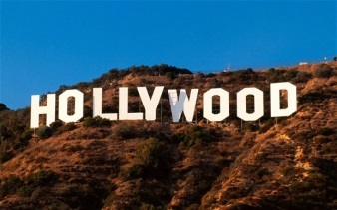New Orleans
6. Atlanta
7. Dallas

* the largest city by population; an important centre of business, finance and art
* the capital city
* renowned for films and the famous actors
* the Kennedy Assassination on November 22, 1963 took place here
* known as the birthplace of jazz and as the centre of French‑American culture.
* in Georgia, is the birthplace of Coca Cola and CNN
* city famous for auto industry in Michigan

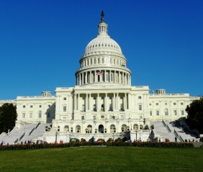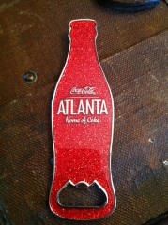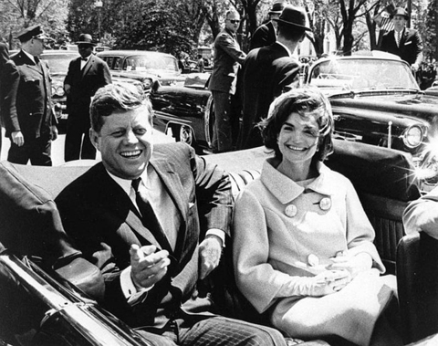 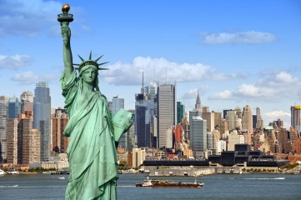

**American sports and pastimes**

B _ _ _ _ _ _ _ is called America’s favourite **pastime**. It is a bat‑and‑ball sport. A person hits a ball thrown at them and tries to run around a **playing field** called a diamond. A _ _ _ _ _ _ _ f _ _ _ _ _ _ _ requires players to run with **an egg‑shaped ball** over the line of the opposition. Players wear **protective padding** and **helmets**. Another popular sport is b _ _ _ _ _ _ _ _ _. The **aim of the game** is to throw a ball through a basket.

# pastime Brit /ˈpɑːsˌtaɪm/ Am /ˈpæsˌtaɪm/

* [something](http://www.macmillandictionary.com/search/british/direct/?q=something) [that](http://www.macmillandictionary.com/search/british/direct/?q=that) [you](http://www.macmillandictionary.com/search/british/direct/?q=you) [do](http://www.macmillandictionary.com/search/british/direct/?q=do) [regularly](http://www.macmillandictionary.com/search/british/direct/?q=regularly) [for](http://www.macmillandictionary.com/search/british/direct/?q=for) [fun](http://www.macmillandictionary.com/search/british/direct/?q=fun) [in](http://www.macmillandictionary.com/search/british/direct/?q=in) [your](http://www.macmillandictionary.com/search/british/direct/?q=your) [free](http://www.macmillandictionary.com/search/british/direct/?q=free) [time](http://www.macmillandictionary.com/search/british/direct/?q=time)

*→* [*Skateboarding*](http://www.macmillandictionary.com/search/british/direct/?q=skateboarding)[*is*](http://www.macmillandictionary.com/search/british/direct/?q=is)[*the*](http://www.macmillandictionary.com/search/british/direct/?q=the)[*favourite*](http://www.macmillandictionary.com/search/british/direct/?q=favourite)[*pastime*](http://www.macmillandictionary.com/search/british/direct/?q=pastime)[*of*](http://www.macmillandictionary.com/search/british/direct/?q=of)[*many*](http://www.macmillandictionary.com/search/british/direct/?q=many)[*teenagers*](http://www.macmillandictionary.com/search/british/direct/?q=teenagers)*.*

**Natural dangers** – name the pictures – use the words from the text

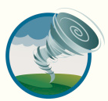The Pacific Basin(west coast) faces danger mainly from **earthquakes**, **volcanoes, forest fires** and **mudslides**, while those living on the Gulf and Atlantic coasts must beware of **hurricanes**. The Midwest suffers mainly from **tornadoes**, as does the southeast.

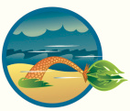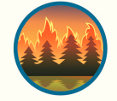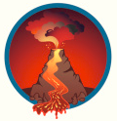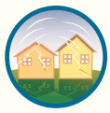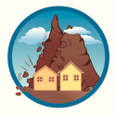

_____________ _____________ ____________ _____________ _____________ ____________

**🗝**

**Basic facts about the United States of America**

50

Alaska

Hawaii

world

language

spoken

**The American system of government**

federal

union

consists

Congress

Senate

House

2

executive

Supreme

**American history**

on the right hand-side – 2,4,1,3

below 1,3,2,4

**Geographical features**

! Canada (not given in the list of words)

! Mexico (not given in the list of words)

landscapes

Rocky

Mount

Alaska

Great

Ontario

system

**Individual states**

Florida

California

Alaska

Louisiana

Hawaii

**Famous cities in the USA**

3,1,4,7,5,6,2

**American sports and pastimes**

Baseball

American football

basketball

**Natural dangers**

mudslide

earthquake

volcano (volcanic eruption)

tornado

forest fire

hurricane