THE AMERICAN SYMBOLS
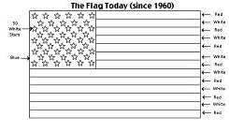
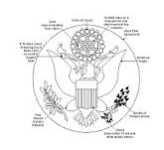
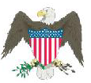
1 2 3

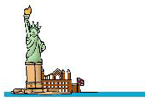
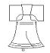
4 5
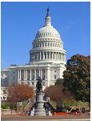
6
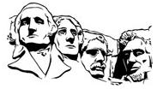

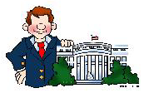
7 8

1) Write the name of each symbol under the picture ( watch out ! There’s an odd one ! )
There are many symbols that represent the United States of America. Some of the most popular ones are :

- the US Capitol
- the Statue of Liberty (a gift from France)
- the bald eagle (our national bird)
- the Stars and Stripes
- The Empire State Building
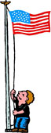
- Mount Rushmore ( on a mountain in South Dakota),
- the Liberty Bell
- the Great Seal of the USA
- the White House

2) What is the correct definition of each symbol ?

a) It represents an American eagle with a ribbon in its beak. The bird is holding an olive branch (symbolizing
peace) and 13 arrows ( for the original 13 colonies and the necessity of war to protect the country).
A shield is in front of the eagle.
b) It is the official residence of the President of the United States of America. It is located at 1600
Pennsylvania Avenue in Washington, D.C., the capital city of the USA.
c) It is a big mountain sculpture of four US Presidents, located in South Dakota. The Presidents depicted are:
George Washington, Thomas Jefferson, Theodore "Teddy" Roosevelt, and Abraham Lincoln. The work was
designed by the sculptor John Gutzon Borglum (March 25, 1871- March 6, 1941).
d) It is a huge bronze bell that symbolizes freedom ( = liberty) in the United States of America.
e) It is a huge sculpture that is located on Liberty Island in New York. The real name of the statue is "Liberty
Enlightening the World."
f) This bird is native from North America ; it has been the national symbol of the USA since 1782.
g) On it, there are : -50 stars representing the 50 states of the USA today
- 13 white and red stripes representing the 13 colonies that existed
when the USA became independent in 1776.
h) This building houses the United States Congress ( a part of the Government) ; it is in Washington,DC.

KEY

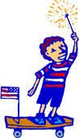
- 1 the bald eagle
2 the Stars and Stripes
3 the Great Seal of the USA
4 the statue of Liberty
5 the Liberty bell
6 Mount Rushmore
7 the White House
8 the Capitol
the odd one is the Empire State Building

2) a3 / b7/ c6 / d5 /e4 / f1 / g2 / h8

