AUSTRALIA DAY
Australia Day is a public holiday in Australia. It is celebrated on January 26 every year and commemorates the arrival of the First Fleet of 11 convict ships from Great Britain, and the raising of the Union Jack at Sydney Cove by its commander Captain Arthur Phillip, in 1788.
What Do People Do?
Many people have a day off work and use the day among other things to barbecue, go to outdoor concerts, play or watch sports events, or simply to spend time with family and friend.
Different places in Australia celebrate the day differently. For example, Sydney has boat races including a ferry race and the tall ships race, while Adelaide celebrates with a parade, concert, fireworks, and a cricket match.
Various music festivals are held on Australia Day, such as the Big Day Out, the Triple J Hottest 100, and the Australia Day Live Concert which is televised nationally. For many years an international cricket match has been held on Australia Day at the Adelaide Oval.
Australian citizenship ceremonies are often held on Australia Day. These are ceremonies to welcome immigrants who have been granted citizenship to the country. Although official, these ceremonies often have a festive atmosphere.

Public Life
Australia Day is a public holiday in all states and territories. All schools and post offices are closed. Some public transport services do not operate, and others run a reduced service. Stores are often open, but may have reduced opening hours. There may be some congestion on roads, particularly close to major events.

Background
January 26 marks the landing of Captain Arthur Phillip at Port Jackson in 1788. The landing is known as the First Fleet and had 11 ships with convicts. The arrival of the First Fleet represents the founding of the colony New South Wales.
In 1818, on the 30th anniversary of the founding of the colony, the Governor of New South Wales gave all government employees a holiday. He also celebrated the day with a 30-gun salute and a ball. In the following years, employees of banks and other organizations were also given holidays.
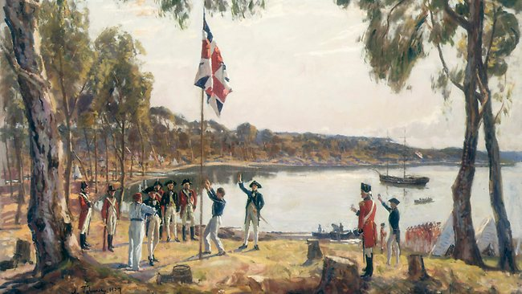
Initially, it was only New South Wales that celebrated the day, and it was known as First Landing Day or Foundation Day. In 1838, 50 years after the First Fleet arrived, Foundation Day was declared Australia's first public holiday in New South Wales.
By 1935, January 26 was known as Australia Day in all states except New South Wales, where it was still called Anniversary Day. From 1946, January 26 was called Australia Day in all states and territories, and since 1994, the Australia Day public holiday has been on January 26 throughout the country.
Because it marks the day of colonization, Aboriginal Australians often feel that the celebrations on Australia Day exclude them. The day has been renamed Invasion Day, and protests do appear side-by-side the celebrations.
In recent years, efforts have been made to make the holiday include all Australians, and in 2013, the Australian flag and Aboriginal flag were raised on the Sydney Harbour Bridge for the first time on Australia Day.

Symbols
The symbols of Australia more commonly used on Australia Day are:
- The Australian national flag, with its representations of the Union Jack, the Commonwealth Star, and the five stars of the Southern Cross.
- The national anthem, Advance Australia Fair, is played, but also Australia’s unofficial anthem, Waltzing Matilda, is a common song to be heard.
- Other symbols include the Golden Wattle, which is the national floral emblem, the opal, which is the national gemstone, and the national colours of green and gold.

The golden wattle
The golden wattle (Acacia pycnantha) is the official floral emblem of Australia. It has served as a national symbol celebrating Australia’s nature and environment since the 1820s. The wattle represents the Australian land and its natural beauty, our shared history, our diversity and our resilience as a people.
Wattle as a symbol also holds meaning for Aboriginal Australians because it is native to this place, rather than being a memorial of our ties with Great Britain. As a symbol of nature, it represents the depth of feeling and connection Aboriginal and Islander peoples have with their land

Commonwealth Star
The Commonwealth Star symbolises the Federation of Australia, when Australia’s six colonies or states became a nation under a single constitution on 1 January 1901.
The Commonwealth Star is the only symbol on the current flag that is uniquely Australian. It is found on our coat of arms, our currency, and the badges of the Australian Defence Force and throughout the Australian Honours system.

