AUSTRALIA AND NEW ZEALAND

AUSTRALIA
Australia is in Australia (also known as Oceania). It is an island, but because it is so large, it is considered as a continent instead. There have been humans on Australia for over 50 000 years. In Australia we find many beautiful natural landscapes, such as the Great Barrier Reef and Ayer’s Rock.
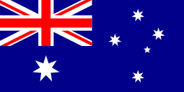
The capital of Australia is Canberra, but the biggest city is Sidney. The flag has six stars, as well as a smaller version of the UK flag in the corner. This is because Australia used to be a British colony. It looks like this:

NEW ZEALAND
New Zealand is just south of Australia, and consists of two islands. It is much smaller than Australia, and there are a lot fewer people living there. There are 24 million (24 000 000) people living in Australia, but only 4 million (4 000 000) in New Zealand.
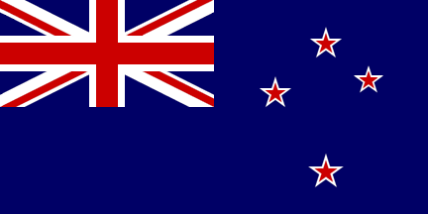
The capital of New Zealand is Wellington. The flag is similar to Australia’s flag, but it only has four stars which are red. Because it is so similar, they are talking about changing it. For now, it looks like this:

DO YOU REMEMBER?

- What is the capital of New Zealand?
_____________________

- What is the capital of Australia?
______________________
- How many people live in New Zealand?
______________________

- How long have people lived in Australia?
______________________

- Why is the UK flag included in the Australian flag?

______________________

- In which continent do we find Australia and New Zealand?
______________________

- How many stars are there in the Australian flag?
______________________

- How many stars are there in New Zealand’s flag?
______________________

DRAW THE FLAGS!

AUSTRALIA NEW ZEALAND

