

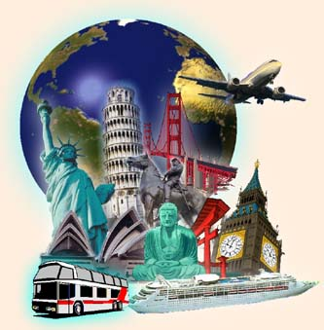

Millions people all over the world like travelling. They travel to see other countries and continents, modern cities and the ruins of ancient towns, they travel to enjoy picturesque places or to learn about other cultures. It's always interesting to discover new things and different ways of life, to meet different people, to try different food, to listen to different music.   
People who live in the country side often like to go to a big city in order to visit museums and art galleries, things they don't have at their hometown. They like to buy in elegant shops and to dine at exotic restaurants. People from the city often like a quiet holiday by the sea or in the mountains where they can sunbath or walk. Many tourists love taking photographs of everything that interest them - the sights of a city, old churches and castles, views of mountains, lakes, valleys, plains, waterfalls, forests, different kinds of trees, flowers and plants, animals and birds.

People travel by train, by plane, by ship or boat and by car. All means of travel have their advantages and disadvantages. And people choose one according to their plans and preferences. The fastest way of travelling - is travelling by plane, but the most comfortable is travelling by ship and the cheapest is travelling on foot.

If we like travelling, we see and learn a lot of things that we can never see or learn at home, though we may read about them in books and newspapers and see pictures of them on TV. The best way to study geography is to travel and the best way to get to know and understand the people is to meet them in their own homes.

**Answer the questions about the text and about you.**

1. Why do people travel?

2. What do you see and learn while travelling?

3. How do people from the countryside like to spend their holidays?

4. How do people from the big cities like to spend their holidays?

5. How can people travel?

6. Which is the fastest mean of transport?

7. Which is the most comfortable mean of transport? Why?

8. What is the best way to study geography?

9. Do you like to travel?

10. What kind of trips do you like? Why?

11. Have you been in a foreign country? Which one? Did you like the experience? Why /not?

11. When traveling, do you try local food? Why / not?

12. Where do you like to stay? Luxury hotel, hostel, camping ...?

13. What is your favourite mean of transport? Why?

14. Do you have plans for your next trip? Where are you planning to go?

15. Do you like better travelling alone or with your family or friends? Why?