DOING A RESEARCH

THE THREE MOST VISITED CITIES IN THE WORLD!

According to an article on Forbes magazine, the three most visited cities in the world by tourists are Bangkok, London and Paris. Do a research on books or on the internet and find these information about them :Language, touristic attractions, typical food, typical drinks and currency.

Number three: Paris, the capital of France.
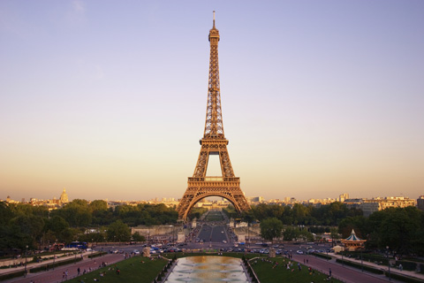
Image from: www.stischooltravel.co.uk

Language: ________________________________________________________________________

Five touristic attractions: ________________________________________________________________________________________________________________________________________________________________________
____________________________________________________________________________________
Three typical food: _________________________________________________________________
____________________________________________________________________________________
Three typical drinks: ________________________________________________________________
____________________________________________________________________________________
Currency:_____________________________________________________________________________________________

Number two: London, capital of the United Kingdom.
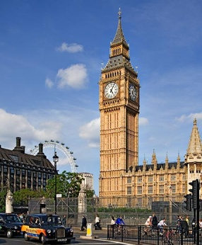
Image from woices.com
Language: ________________________________________________________________________

Five touristic attractions: ________________________________________________________________________________________________________________________________________________________________________
____________________________________________________________________________________
Three typical food: _________________________________________________________________
____________________________________________________________________________________
Three typical drinks: ______________________________________________________________
____________________________________________________________________________________
Currency:_____________________________________________________________________________________________

Number one: : Bangkok, the capital of Thailand.
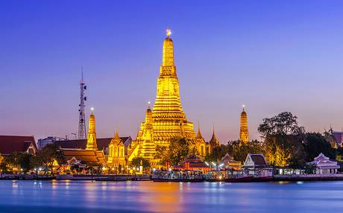
Image from: www.telegraph.co.uk

Language: ________________________________________________________________________

Five touristic attractions: ________________________________________________________________________________________________________________________________________________________________________
____________________________________________________________________________________
Three typical food: _________________________________________________________________
____________________________________________________________________________________
Three typical drinks: _______________________________________________________________
____________________________________________________________________________________
Currency:_____________________________________________________________________________________________

What is your favorite city? Write a short text telling why.

_________________________________________________________________________
_________________________________________________________________________
_________________________________________________________________________

