Who lives in Canada?
- My uncle ………………………. in Canada.  - …………… you ……………………. English?  - How often ………………… your mum …………………….. a cake?  - …………….. you ………………… grapefruit juice?  - My friend ……………………………….. pineapples.  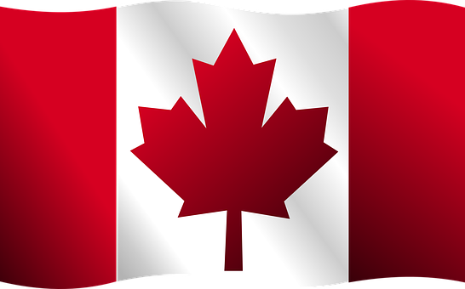  - ……………… you allergic to milk?  - My friend ………………………… tennis.  - Our teacher often …………………… jeans.  - ………………. your parents ……………………… TV every evening?  - Where ………………….. Tom and Rebecca …………………..?  - I always ………………….. cereal for breakfast.  - I …………………… addicted to sweets.  - My classmates ………………………… history.  - Amelia ……………………….. a lot of books.  - The baby often ……………………. at night.  - ……………….. you ………………………. early on Saturdays?  - My cousin ……………………… the guitar.  - My PE teacher ……………………. a bike every day.  - …………………. your aunt …………………. in the bank?  - We …………………………….. cola for lunch.  - Linda …………………………… to New York three times a year.  - They ………………………………… to the gym every day.  - Patrick and me often ……………………… videos on YouTube.  - Gina ……………………. my brother’s girlfriend.  - Kids ………………………… fast food. | LIVE  SPEAK  MAKE  LIKE  NOT EAT  BE  NOT PLAY  WEAR  WATCH  WORK  EAT  NOT BE  NOT LIKE  READ  CRY  GET UP  PLAY  RIDE  WORK  NOT DRINK  FLY  NOT GO  UPLOAD  BE  LOVE

