**1. Complete the gaps by a personal pronoun.**

1. My name is Ann. _______ am 10 years old.

       2. Pedro and Pablo are my friends. _______ are from Mexico.

       3. Pedro and Pablo look alike and most people ask them, "Are _______ twins?"

       4. Pedro and I like to play tennis. _______ play at the club.

       5. Pablo likes to play football. _______ plays with his neighbours.

       6. Linda is my sister. _______ does not like sports.

       7. My older brother has a horse. _______ is a gentle mare.

       8. He asked, "Linda, do _______ want to go horseback riding?"

**2. Replace the words in brackets by a personal pronoun.**

       1.  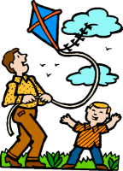  _______ is flying a kite. (Dad)

      2. 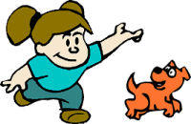 _______ is playing with her dog. (The girl)

      3. 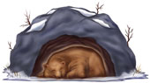 _______ sleeps the whole winter! (The bear)

      4.  _______ like to sing! (My friend and I)

      5.  My name is Bill. _______ like to play baseball. (Bill)

      6. 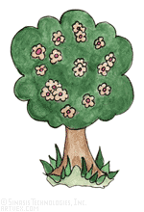 _______ has pretty pink flowers. (The tree)